DIARY OF MY SCHOOL TRIP TO

CHELTENHAM (UK)
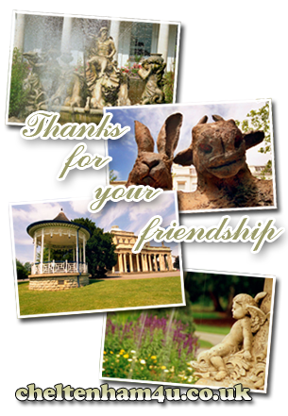

JUNE 20-27, 2010

3 ESO BILINGUAL SECTION.
IES JOVELLANOS, GIJON

NAME……………………………………………………………...

- Before you travel

  - Where is Cheltenham? Place it on the map below.

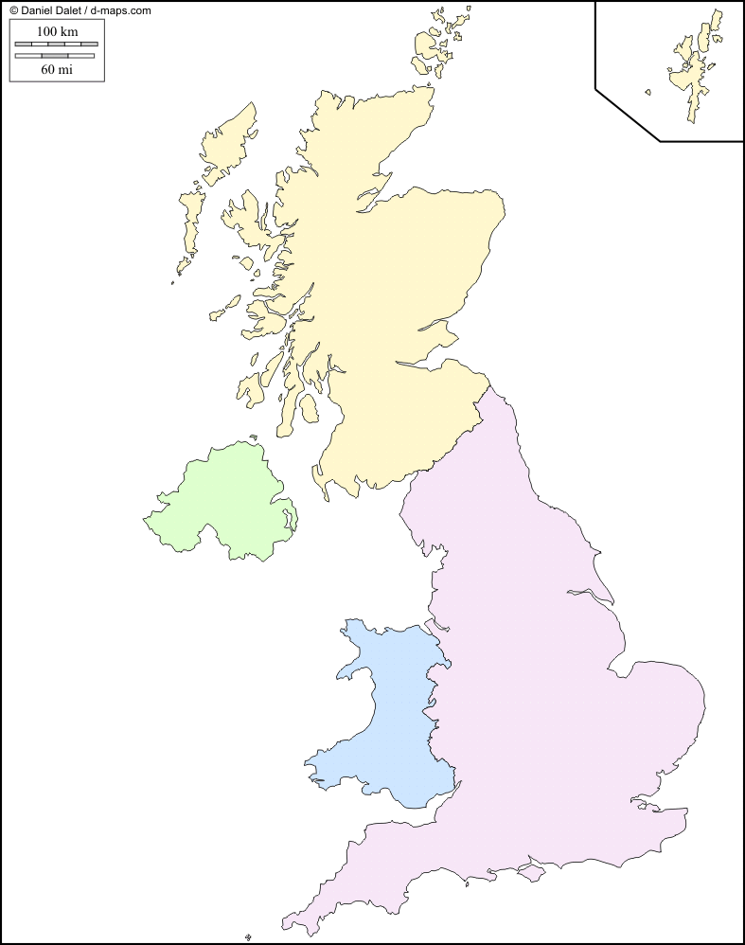

  - What do you know about this town? What do you expect to find there?

  - Find information about Cheltenham, including:

      - Population

      - Places of interest

      - Important festivals & celebrations

      - A bit of history

- Diary

Day 1. Date: …………………..

The flight.

- Flight number:

- Departure time:

- Arrival time:

- Name of airport:

- Did you enjoy the flight?

Coach transfer to Cheltenham

First impressions of the city and your host family

Day 2. Date: …………………..

- Morning: lessons

- Afternoon: trip to Stratford upon Avon

- Evening: with your host family

(stick a photo here)

Day 3. Date: …………………..

- Morning: lessons

- Afternoon: project work at school

- Evening: with your host family

(stick a photo here)

Day 4. Date: …………………..

(stick a photo here)

- Morning and afternoon: trip to London

- Evening: with your host family

Day 5. Date: …………………..

- Morning: lessons

- Afternoon: trip to Gloucester

- Evening: with your host family

(stick a photo here)

Day 6. Date: …………………..

- Morning: lessons

- Afternoon: excursion to Cadbury’s Chocolate factory

- Evening: with your host family

(stick a photo here)

Day 7. Date: …………………..

- Morning and afternoon: trip to Bath

- Evening: with your host family

(stick a photo here)

Day 8. Date:…………………..

Back home

- Flight number:

- Departure time:

- Arrival time:

- Did you enjoy the flight?

On balance

- Did you enjoy the experience? Why / why not?

- Was it similar to / different from what you expected to find? Why?

- What were the best and the worst things?

- Would you recommend it to a friend? Why/why not?

- Notes about…..

- The city: places of interest, shops, leisure facilities (parks, restaurants and pubs, cinemas and theatres, sports…), transport, atmosphere…

- The school: the buildings, rooms, computer facilities, staff, lessons…

- Your host family: names, ages, jobs, hobbies, pets, the house (type of house, rooms, gardens…), your bedroom, the meals…

- The country: the people, the weather, cities, landscape, transport and traffic, curious things…

