A PORTRAIT OF LINNAEUS

WHAT DO YOU KNOW ABOUT THE FATHER OF TAXONOMY?

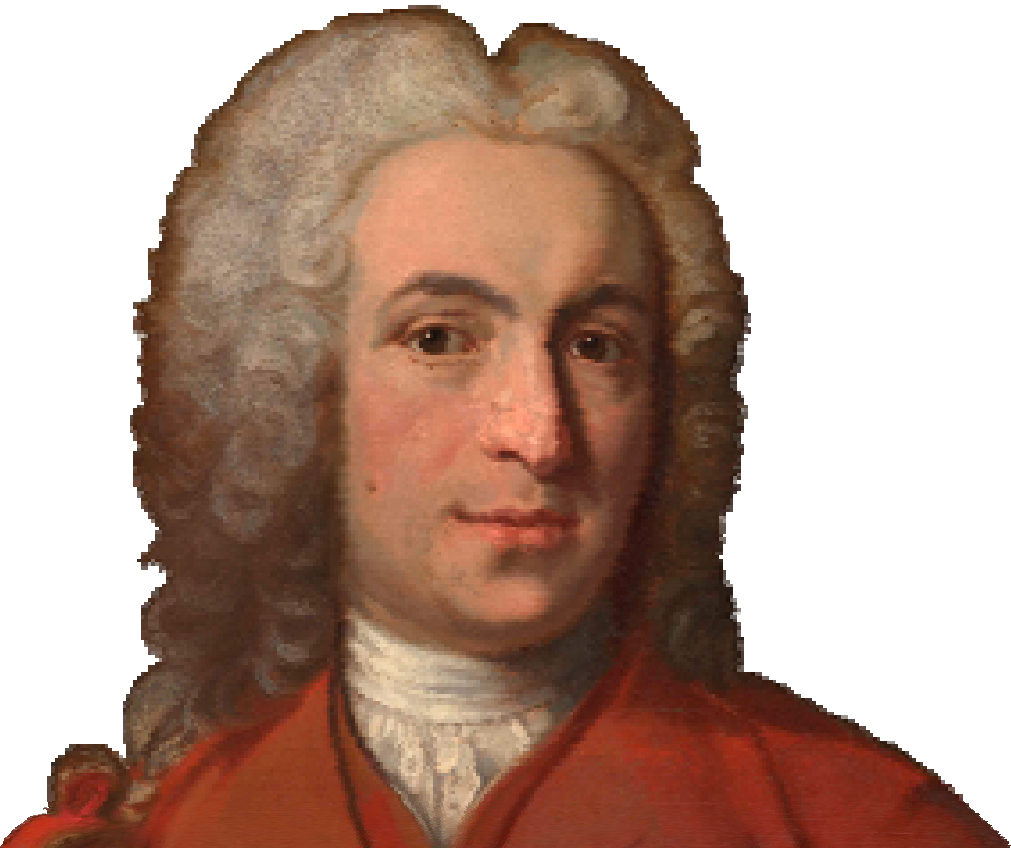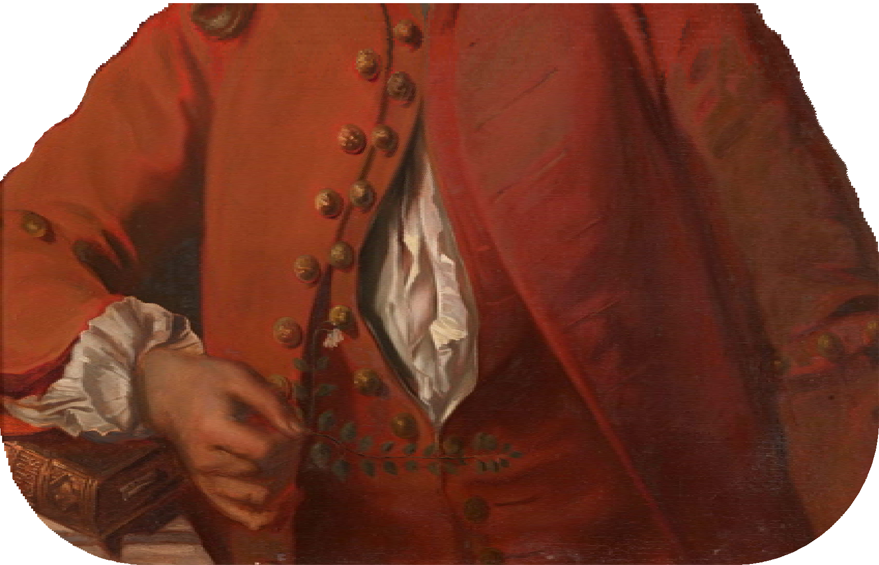

Do a little research and write a short text that answers the following questions:

 Who was Carl Linnaeus?
 Where did he come from?
 What were the major events in his life?
 What were his contributions to science?
 Why were they important?
 How do they relate to science today?

Useful websites
www.linnean.org
The Linnean Society of London

www.linnean-online.org
Linnaeus¨collection online

www.linnaeus.se/eng/index.html
The Swedish Linnaeus Society

www.linnaeus.uu.se/online/index‐en.html
An extensive portal from the University of Uppsala, Sweden, to information on Linnaeus

www.nhm.ac.uk/nature‐online/science‐of‐natural‐history/biographies/linnaeus/index.html Information on Linnaeus from the Natural History Museum, London

linnaeus.nrm.se/botany/fbo/welcome.html.en
The Linnaean Herbarium at the Swedish Museum of Natural History

www.ucmp.berkeley.edu/history/linnaeus.html
A biography of Linnaeus from the University of California, Museum of Palaeontology
