FROSTY THE SNOWMAN

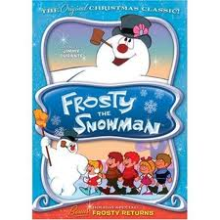
Frosty the Snowman
Was a jolly happy soul
With a corncob pipe and a button nose
And two eyes made out of coal
Frosty the Snowman
Is a fairytale, they say
He was made of snow but the children know
How he came to life one day
There must have been some magic
In that old silk hat they found
For when they placed it on his head
He began to dance around
Frosty the Snowman
Was alive as he could be
And the children say he could laugh and play
Just the same as you and me
Frosty the Snowman
Knew the sun was hot that day
So he said, "Let's run and we'll have some fun
Now before I melt away"
Down to the village
With a broomstick in his hand
Running here and there, all around the square,
Sayin', "Catch me if you can"
He led them down the streets of town
Right to the traffic cop
And he only paused a moment
When he heard him holler, "Stop!"
Frosty the Snowman
Had to hurry on his way
But he waved goodbye, sayin' "Don't you cry,
I'll be back again some day."
Thumpety thump thump
Thumpety thump thump
Look at Frosty go
Thumpety thump thump
Thumpety thump thump
Over the hills of snow

Video with lyrics: http://www.youtube.com/watch?v=zGDi8TqqeX8
Video – Karaoke: http://www.youtube.com/watch?v=TQyStHYel1c

