Living things

Read the following text and answer the questions:

A cell is the structural unit of living things, but not all living things have the same type of cells.
Animals have cells called eukaryotic cells, which have two distinct areas: the nucleus and the cytoplasm. The nucleus stores the DNA with genetic information and it is different for each individual. The cytoplasm hosts other organelles that perform different functions. It is surrounded by a cell membrane, through which some substances go in and out. The nucleus is also surrounded by a nuclear membrane that separates it from the cytoplasm. There is a structure joined to this membrane called endoplasmic reticulum, which is essential in the formation of biomolecules.
Plants have cells which are similar to animal cells. The main difference is the cell wall that protects the cell membrane and provides rigidity and resistance to the cell.
Finally, the simplest organisms, such as bacteria, have more primitive cells called prokaryotic cells. They do not have a distinct number, but their genetic material is dispersed in the cytoplasm, producing a structure that is called a nucleoid. The majority of these organisms contain a rigid wall cell that protects the cellular membrane and shapes the organism.

ACTIVITIES
1. Identify the type of cell that is shown in the pictures and label the structures under each cell.

Cell wall, cell membrane, Cell membrane, nucleus Cell wall, cell membrane,
cytoplasm and nucleoid. and cytoplasm. nucleus and cytoplasm.

2. In the news and television series that deal with police investigation they identify the person that has acted against the law by carrying out a study of DNA. To do so, forensic doctors try to locate some elements of this individual in the crime scene: a drop of blood, a hair, saliva, remains of skin and so on. Explain why the result of the analysis is valid for any type of cell.

Read the following text and answer the questions:

Bacteria can be found in the smallest living things; they are prokaryotic unicellular organisms. Even though their presence is associated with many illnesses, not all bacteria are harmful. Plenty of them produce benefits, such as the intestinal flora that are in the digestive system. There, they produce some vitamins and help in the process of digesting certain foods. Others foster the decomposition of organic matter and its transformation into other more useful products, such as fermenting bacteria that allow the manufacture of yogurt or vinegar. Finally, there are other bacteria that produce illnesses or even death when they enter an organism. These are called pathogenic bacteria and some of the common ones cause caries, meningitis, pharyngitis, tuberculosis, digestive ulcers or pneumonia. Antibiotics are used to treat bacterial diseases.

But the smallest organisms that exist are viruses. They are not made up of cells, but only nucleic acid (genetic material) wrapped in a protein capsule. Viruses need to break into a cell in order to reproduce, and they do it using the genetic material of that cell. Outside a cell, they are inert. Viruses are responsible from some illnesses such as AIDS, influenza, cold, hepatitis, measles and some cancers. Specific medications called antivirals have been developed to treat these illnesses. They are only used when the illness is severe, since they can attack healthy cells.

Some authors consider that viruses are not actual living things. The most classic definition of living things states that they are organisms that perform several functions. In the first place, nutrition, with which they obtain the matter and energy they need to survive. In the second place, interaction, which allows them to know the environment that surrounds them and respond to its changes. For instance, animals escape when they are in danger, plants turn to the light and bacteria respond to light and chemical stimuli. Finally, reproduction, through which an organism produces another one the same as it.

ACTIVITIES

3. Why do some authors consider that viruses are not living things? Support your answer.

4. A cough or sore throat are frequent symptoms in many illnesses such as a cold, influenza, pharyngitis or pneumonia. Doctors insist on the importance of not self-medicating with antibiotics, because they can be completely inefficient against an illness and cause other harmful effects. Review the text and say which of these illnesses can be treated with antibiotics.

Now, read this text and answer the question:

Fungi are also classified as microorganisms, but they are made up of eukaryotic cells. They can be unicellular or multicellular and their size varies from microscopic organisms, such as yeasts, to the mushrooms that we can find in the countryside or the supermarket.

Moulds are multicellular fungi made up of rope-like structures called hyphae. They intertwine forming a cottony structure, as we can see in decayed fresh food. The mould Penicillium from which penicillin is obtained belongs to this group. Other examples that also belong to this group are the ones that cause athlete’s foot disease or the ones that take part in the formation of some cheeses such as Roquefort or Camembert. The majority of them are found in damp environments, although there are also others that live in dry environments.
The English scientist Alexander Fleming accidentally discovered that the fungi known as Penicillium inhibits the growth of some pathogenic bacteria. A dish in his laboratory in which the bacterium Staphylococcus aureus was growing became accidentally contaminated with the fungi Penicillium.

When he incubated the bacteria he noticed that in the areas that were closest to the fungi, the bacteria did not grow. Subsequent studies allowed the isolation of the penicillin antibiotic from this fungus, which was the agent that inhibited the growth of the bacteria.

These studies were carried out by the scientists Ernst Boris Chain and Howard Walter Florey. The Nobel Prize for Medicine was awarded to them along with Fleming in 1945.

ACTIVITIES

5. Some people consider that Fleming’s discovery was completely by chance and he should not have been awarded the Nobel Prize for it. Give a reason that justifies that the discovery of penicillin is a scientific work.

Read the text and answer the question:

When someone suffers from a serious infection produced by an unidentified bacterium, an antibiogram is done in order to choose the most suitable antibiotic to treat it. To do so, a sample that contains the bacteria is placed in a dish. It can be urine, mucus, pulmonary liquid, etc.

Small discs that contain different antibiotics identified with a letter are placed on top of the bacteria. The bacteria are incubated and the dish is observed.

The most suitable antibiotics to overcome the illness are the ones that inhibit the growth of the surrounding bacteria the most.

ACTIVITIES

6. In a laboratory it is necessary to know the most suitable antibiotic in order to deal with a pulmonary infection. A dish with the bacteria has discs with antibiotics placed on it, as shown in the drawing on the left, and, after a certain time span, the result on the right can be observed.

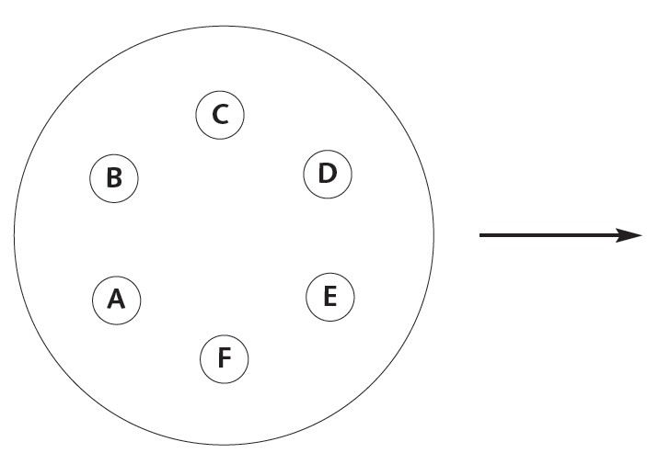

a) Say which is the most effective antibiotic to overcome this infection.
b) And the least effective?
c) Explain your answers to the questions above giving reasons.

